Conditional Statements Demo

Video at <https://youtu.be/P7mA0_LWQCk>

1. Start our program
   1. Start Visual Studio
   2. Create a new empty C++ project:
   3. Call it “ConditionalDemo”, pick the desktop as the location and click OK.
   4. Click on Source Files and Add|New Item:

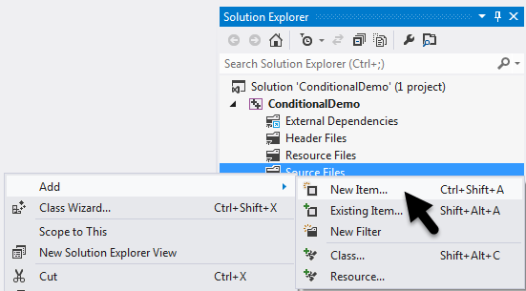

* 1. Select Visual C++, C++ File (.cpp), call it “ConditionalDemo”, then click “Add”:

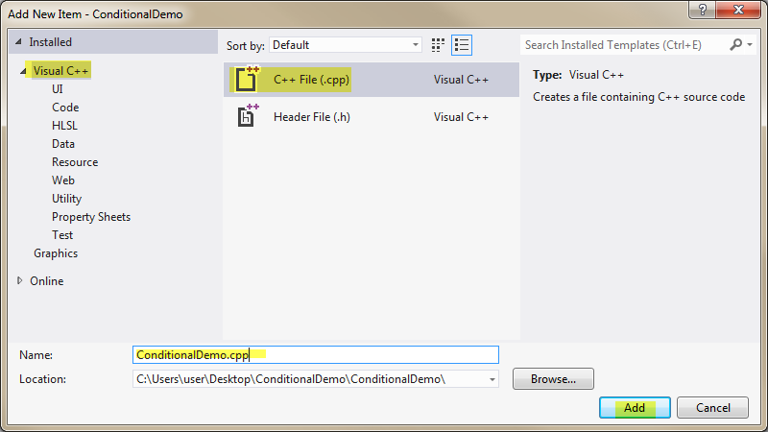

* 1. You should now have “DeclarationDemo.cpp” in the solution explorer and it should be open in the main window:

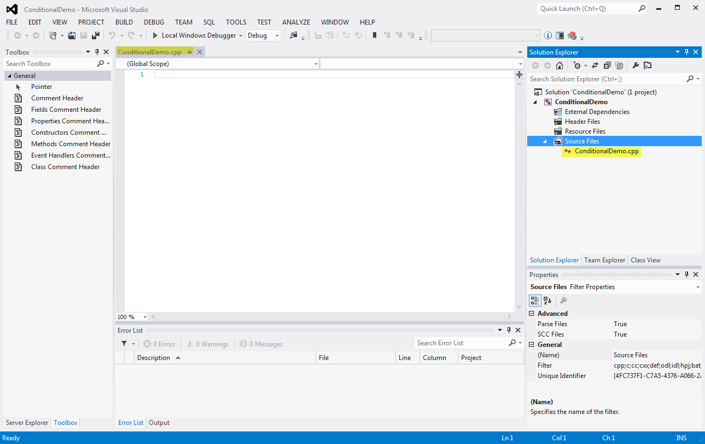

* 1. Enter the following code to start our program:

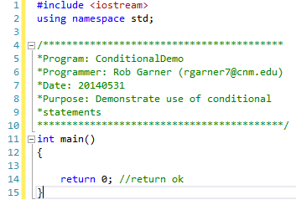

1. Demo If Then statement:
   1. Add the following code:

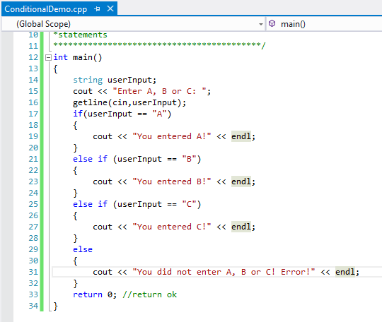

* 1. Try it with Ctrl-F5:

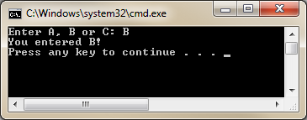

* 1. Notice that execution goes through the if then statement associated with the value you enter. Notice that if you enter anything other than A, B or C the last else is executed and reports an error to the user. This is a common way to structure if then else statements.
  2. Set a break point and step through the code in debug mode to see how it works.
  3. Change the code as follows:

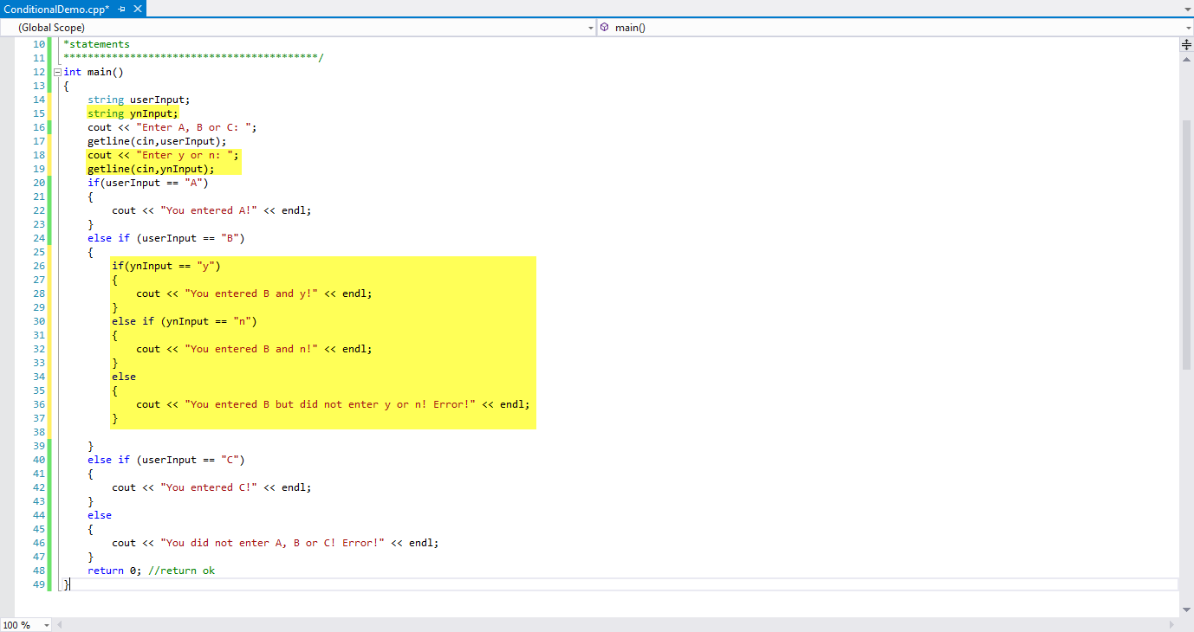

* 1. Try it with Ctrl-F5:

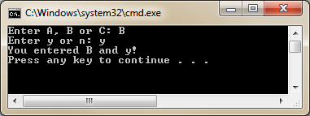

* 1. Set a break point and step through the code in debug mode to see how it works.

1. Demo ternary operator:
   1. Replace the code with the following:

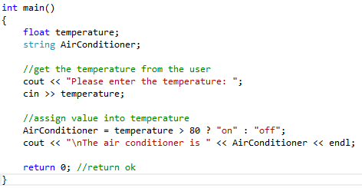

* 1. Try it with Ctrl-F5:

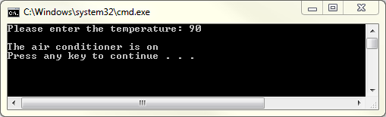

* 1. Set a break point and step through the code in debug mode to see how it works.
  2. Change the code to:

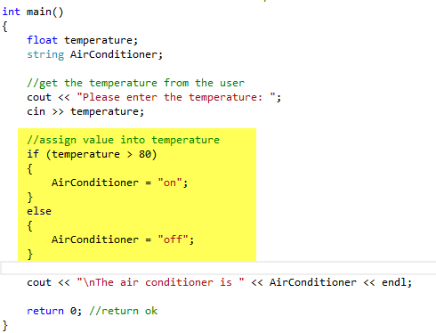

1. Switch Statement
   1. Change the code to:

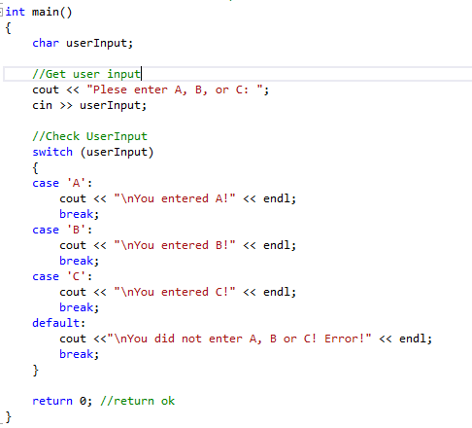

* 1. Try it with Ctrl-F5:

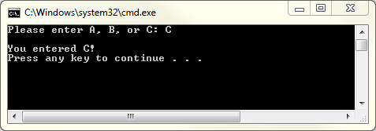

* 1. Set a break point and step through the code in debug mode to see how it works.